COMMUNCATION PRODUCTS

Tablet PC with website passed around

PowerPoint Slides

Handouts for each client
- Site Map

KEY POINTS

1) Thorough analysis and understanding of client and user needs
2) Context-sensitive approach to information delivery

3) Efficient registration and shopping facilities
Introduction

Good morning gentlemen and welcome to our presentation.

We are Super Team Formation Unit, STFU for short, and we a trio of very experienced and dedicated web designers. Today we are here to tell you why our website proposal for the Echo Bay Games Expo will be the best choice for the success of your Expo.

STFU comprises myself - Lachlan George (Project Leader) - , Bodaniel Jeanes (Senior Technical Advisor), and Ross Brackstone (Senior Design Engineer). In our presentation today Ross will explain our client and user needs analysis, site identity and composition and he will conclude the presentation. Bo will explain how our analysis has influenced the site design and will take yout through the context-sensitive navigation structure of our site prototype. navigationI will direct proceedings. It is our individual expertise and our ability to function well as a team, which has lead to the quality of the design being presented to you today.

When STFU was first approached about designing a website concept for the Echo Bay Games Expo our first step was to make sure we had a clear understanding of your needs. Our summarisation of the business case led us to identify the following points as your reasons for the project:
  - To compliment your other promotional strategies
  - To help cope with your anticipated increase in demand for information and ticketing
  - To expand new marketing opportunities (sales and merchandise)
  - To better utilise existing your resources

With these objectives in mind and against the background of our comprehensive expertise in web design STFU began an intensive analysis of your user market. Our thorough user and client needs analysis has resulted in a website which features a context-sensitive approach to information delivery and provides efficient registration and sales facilities. We believed our product will be attractive to web users and meet your needs as the Expo’s organising committee.

Ross will begin by taking you through our analysis of client and user needs.

Throughout our presentation we encourage you to peruse our website via the tablet pc.

Body

ROSS

As part of our design process STFU undertook a thorough process of user and client needs analysis. The outcomes from this analysis generated a number of what we believe are necessary design elements.

Our research showed us that the average age of game players is 30 years of age, and that the average age of the most frequent game purchaser is 37. These statistics support the need to cater for an older audience. Thus we decided the website should focus on the 15+ age demographic as it represents the most significant percentage of the gaming industry, your target audience.

Now that we had excluded the children’s age group we found that Strategy, First Person Shooters, and Role Playing games are the most popular genres in the gaming industry.
(Show figures from analysis)
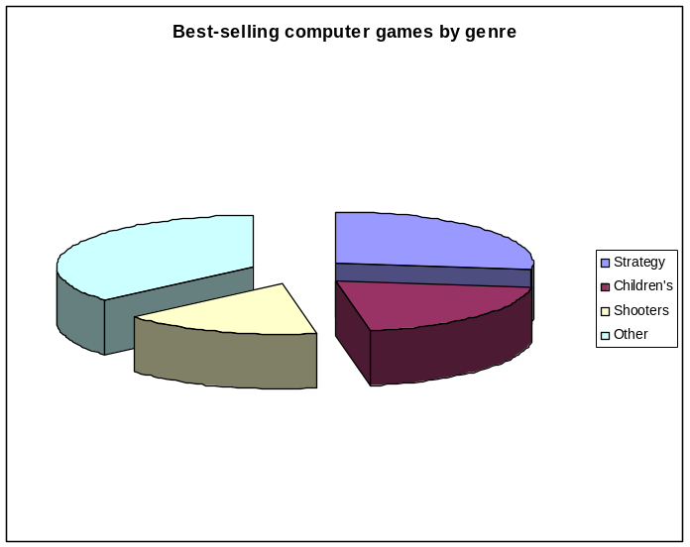
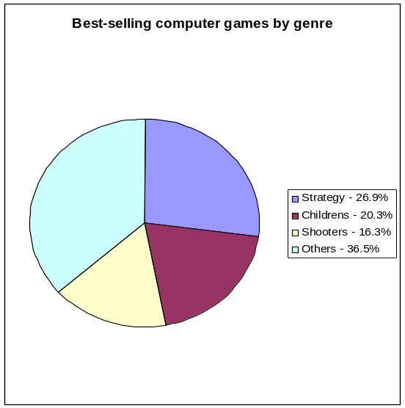

Role Playing (Online and Single Player | First Person Shooters | Strategy
World of Warcraft  Dungeons & Dragons Online: Stormreach  Guild Wars  Elders Scrolls 4: Oblivion | Battlefield 2  Call of Duty 2 | Star Wars: Empire at War  Lord of the Rings: Battle for Middle Earth II  Civilization 4  Age of Empires III

(Show how this has been incorporated into the header and style etc).

Pictures means this…
Logo does this… (feeling of action etc)…

BO

We have used this information specifically in the design of your website.

Having defined our demographic as gamers, developer and hardware manufacturers/retailers from the analysis we also identified the press or media as another key user. By targeting the media we believe that we can generate greater exposure for the Expo.

From the perspective of these audiences they would want the website to:

- Provide appropriate information about the event, specific to each audience.

This includes thing such as the event date/time, ticket info, what’s on in terms of seminars or guest speakers, and what will be showcased (games and technology).
(show PowerPoint of the showcase section)

- Allow for the purchase of tickets.

- Keep them up to date with the latest Expo news.

- If they were developers, to gain exposure to Australia’s gaming community.

- Allow event and exhibit registration.

- Provide an attractive place for manufacturers and retailers to advertise and sell their products.

We combined these with your aim of exposing developers to the cultural and lifestyle aspects of the Echo Bay region.
(Show PowerPoint of Echo Bay lifestyle and region)

While the site is focused on information delivery, sales and merchandising, and promotion, it needs to be both fun and professional. It will cater to these groups in the following way:
- gamers (fun),
- developers (fun/professional),
- hardware manufactures/retailers (professional), and
- Press (fun/professional).
We wanted your site to be seen as a serious business, which caters for the needs of both its audiences and you, the client. Our design will set you apart from competing events and bring something unique to the community.

ROSS

STFU has chosen Verdana as the font to be used for the body of the text on-screen, and Georgia as the font for on-paper (such as when a user prints content from the site) and for text that needs to stand out (such as quotes).

We have chosen a range of shades of blue for the majority of the site’s colour. The colour blue is proven to be extremely effective in promoting and advertising technological products (video gaming has its basis in modern technology) and provides a sleek, polished feel. (Show slides of colour and how these work on the website)

Two additional colours that make up the design are a light beige colour and a bright yellow/gold colour. The beige will be used primarily for the font colour and for glows around titles. The bright yellow/gold colour is to be used in the logo and highlights (such as borders around images). The logo will combine the yellow with other bright, hot colours to ignite the sense of action and intense energy. The contrast between the blues will also draw the eye to the logo to intensify these feelings.

BO

Our solution has two important features:

1) We have developed an approach to information delivery which is sensitive to the content outlined above.

Show the front splash page with 3 sections.
Show the global navigation at the bottom of each page.
Show the context-sensitive navigation on the left hand side.

LACHLAN

2) Importantly this site also meets the business needs of your committee.
It provides efficient registration and sales facilities which will link to the database you are already using.

Demonstrate the registration, login, and shopping facilities.

Takes the pressure of call centre, reducing costs.

Helps coping with anticipated demand for ticketing.

Makes the products available to a wider audience and reduces overheads that come with setting up a physical shop front.
ROSS

Conclusion

